**Project Design Phase-I**

**Solution Architecture**

|  |  |
| --- | --- |
| Team ID | PNT2022TMID40035 |
| Project Name | Smart crop production system for agriculture |

**Solution Architecture Diagram:**

Transformer

Regulator

Work station

Dustbin with Ultra sonic sensor

Arduino

App

notificat

ion

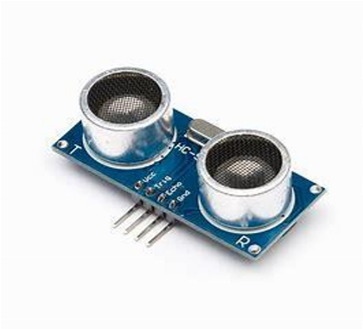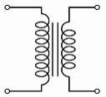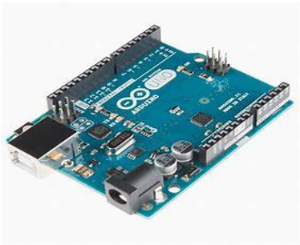

Web

serve

r